UNIT 4 GRAMMAR

Narrative tenses
We use different past tenses to describe moments and periods of time in the past.
Past Simple
Form
The form of the Past Simple is the same for all persons.
He left at three o’clock.
They arrived three weeks ago.
She didn’t finish on time yesterday.
I didn’t visit my parents last weekend.
When did he finish the report?
What time did they leave?
Short answer
Did you enjoy the meal? Yes, we did./No, we didn’t.
Use
The Past Simple is used to express:
1 a finished action in the past.
We met in 2000.
John left two minutes ago.
2 actions that follow each other in a story.
Mary walked into the room and stopped. She listened carefully.
She heard a noise coming from behind the curtain and …
3 a past situation or habit.
When I was a child, we lived in a small house by the sea. Every day, I walked for miles on the beach with my dog.
This use is often expressed with used to.
We used to live in a small house …
I used to walk for miles …
Spelling of verb + -ed
1 Most regular verbs add -ed to the base form of the verb.
worked wanted helped washed
2 When the verb ends in -e, add -d.
liked used hated cared
3 If the verb has only one syllable, with one vowel + one consonant, double the consonant before adding -ed.
stopped planned robbed
But we write cooked, seated, and moaned because there are two vowels before the consonant.
4 The consonant is not doubled if it is -y or -w.
played showed
5 In most two-syllable verbs, the end consonant is doubled if the stress is on the second syllable.
pre’ferred ad’mitted
But we write ‘entered and ‘visited because the stress is on the first syllable.
6 Verbs that end in a consonant + -y change the -y to -ied.
carried hurried buried
But we write enjoyed, because it ends in a vowel + -y.
There are many common irregular verbs.

Past Simple and time expressions
Look at the time expressions that are common with the Past simple.
I met her ...
last night.
in 2001.
two days ago.
in summer.
yesterday morning.
when I was young.
Past Continuous
Form
was/were + verb + -ing
I was learning French. They were driving to Paris.
We weren’t waiting for a long time.
What were they doing? Where was he studying?
Short answer
Were you looking for me? Yes, I was./No, I wasn’t.
Were they waiting outside? Yes, they were./No, they weren’t.
Use
The Past Continuous is used:
1 to express activities in progress before, and probably after, a particular time in the past.
At seven o’clock this morning, I was having my breakfast.
You made a lot of noise last night. What were you doing?
2 for descriptions
It was a lovely day and the sun was shining. Jan looked beautiful. She was wearing a green cotton dress.
3 to express an interrupted past activity.
When the phone rang, I was having a shower.
While we were playing tennis, it started to rain.
4 to express an incomplete activity.
I was reading a book during the flight. (I didn’t finish it.)
Past Simple or Past Continuous?
1 Sometimes both tenses are possible. The Past Simple focuses on past actions as complete facts. The Past Continuous focuses on the duration of past activities, often describing being in the middle of them. Compare:
A I didn’t see you at the party last night.
B No. I stayed at home and watched the football.
A I phoned at 8.00, but you didn’t answer.
B Sorry, I was watching the football.
2 Questions in the Past Simple and Past Continuous refer to different time periods. The Past Continuous asks about activities that began before; the Past Simple asks about what happened after.
A What were you doing when the accident happened?
B I was shopping.
A What did you do when you saw the accident?
B I phoned the police.
used to
Used to expresses a habit or state in the past that is now finished.
I used to read comics when I was a kid. (but I don’t now)
Did you use to read comics when you were a child?
This town didn’t use to be a nice place to live, but then it changed.
Past Perfect
The Past Perfect refers to an action in the past that was completed before another action in the past.
Form
The form of the Past Perfect is the same for all persons.
Positive and negative
I/You/We'd/hadn't left when the post came.
Question
Where had you/she/they been before?
Short answer
Had he already left? Yes, he had./No, he hadn't.
Use
1 The Past Perfect is used to make clear that one action in the past happened before another action in the past.
When I got to my car, I saw that someone had broken into it.
I didn’t go to the cinema because I’d seen the film before.
2 The Past Simple tells a story in chronological order.
Sue met Pete at university. They got married. They were together for six years. They divorced last month.
The Past Perfect can be used to tell a story in a different order.
Sue and Pete divorced last month. They’d met at university, and had been together for six years.
3 Notice the difference between these sentences.
When I got to the party, Peter went home.
(= First I arrived, then Peter left.)
When I got to the party, Peter had gone home.
(= First Peter left, then I arrived.)
4 The Past Perfect Continuous refers to longer actions or repeated activities.
We were exhausted because we’d been driving all day.
I went to the doctor because I’d been having a lot of headaches.

Past tenses in the passive
Form
Past Simple passive: was/were + past participle
The museum was opened in 1987.
Past continuous passive: was/were being + past participle
The trees were being cut down.
Past Perfect passive: had been + past participle
The house had been redecorated.
Use
The uses are the same in the passive as in the active.
The bridge was built in 1876. (finished action in the past)
The bridge was being repaired when it collapsed. (interrupted past activity)
The letter didn’t arrive because it had been sent to my old address. (one action before another action in the past)

Match the picture numbers with the verbs in the box.
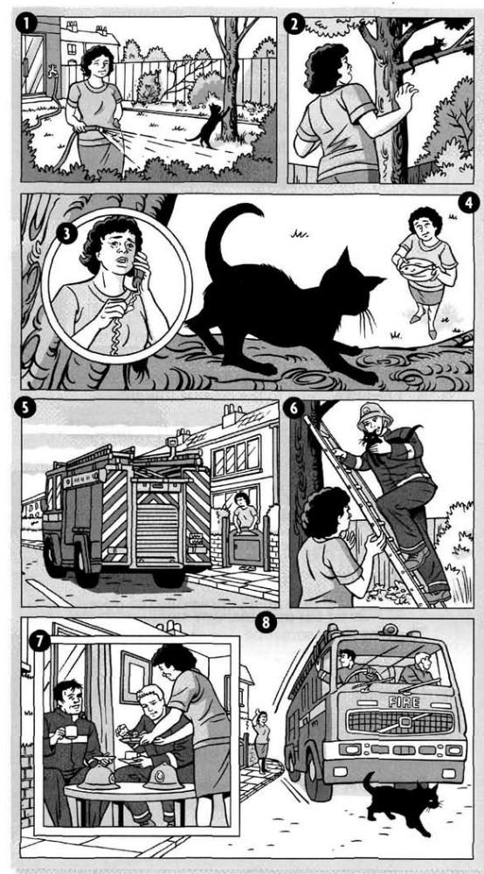 | PAST SIMPLE  __ ran up  __ killed  __ arrived  __ put up  __ called  __ rang  __ rescued  __ ran him over  __ couldn’t get down  __ invited them for tea  __ tried to tempt him down | PAST CONTINUOUS  __ was waiting  _1_ was watering the plants  __ were leaving  _1_ was playing  __ were having tea
Complete the story with the phrases in the box.

YESTERDAY EVENING, Mrs Taylor (1) was watering the plants in her garden, while her cat, Billy, (2) ____________ near her. Suddenly, Billy (3) ____________ a tree. Mrs Taylor (4) ____________ to Billy, but he (5) ____________ , so she (6) ____________ the Fire Brigade. While she (7) ____________ for them to arrive, she (8) ____________ with some fish. The Fire Brigade eventually (9) ____________ , (10) ____________ their ladder and (11) ____________ Billy. Mrs Taylor was so pleased that she (12) ____________. While they (13) ____________ , they didn't see Billy go outside again, and ten minutes later as they
(14) ____________ , they (15) ____________ and unfortunately they (16) ____________him.

Correct these false statements about the story.
1 The story happened last month.
The story didn't happen last month. It happened yesterday evening.
2 Mrs Taylor was cutting the grass.
3 Billy was sleeping in the garden.
4 Billy jumped over the wall.
5 Mrs Taylor rang the Police.
6 The Fire Brigade used a rope to get Billy down.
Choose the correct form of the verb.
1 They fell/ were falling in love when they worked / were working in Rome.
2 She read/ was reading quietly in her room when suddenly the lights went / were going out and she heard/ was hearing a scream.
3 He stood / was standing up, walked / was walking across the room, and closed / was closing the window.
4 A young woman walked / was walking into the office. She carried / was carrying a baby.
5 Didn't you meet / Weren't you meeting your wife while you lived/ were living in Italy?
6 I saw / was seeing you in the park yesterday. You sat/ were sitting with your arm round Tom.
7 As soon as I walked / was walking into the room, she handed/ was handing me the letter.
8 His father was really angry with him because he listened/ was listening to music while he did / was doing his homework.
9 Why didn't they visit/ weren't they visiting me when they stayed/ were staying in London? 10 What did you write / were you writing when your computer crashed/ was crashing?

Complete the text with the correct form of the verbs, Past Simple or Past Continuous.
Last February, I (1) decided (decide) to go on holiday to Florida. The day I (2) __________ (leave) England it (3) __________ (rain), but when I (4) __________ (land) in Florida, the sun (5) __________ (shine) and a lovely, warm breeze (6) __________ (blow) from the sea. I (7) __________ (take) a taxi to my hotel. As I (8) __________ (check in), someone (9) ___________ (tap) me on the shoulder. I (10) __________ (can not) believe my eyes! It was my old girlfriend. She (11) __________ (stay) at the same hotel. The next day, we (12) __________ (go) snorkelling and (13) __________ (see) hundreds of beautiful fish. It (14) __________ (get) dark when we (15) __________ (return) to our hotel after a wonderful day. We (16) __________ (spend) the rest of the week together. It was very romantic. We (17) __________ (feel) very sad when the holiday (18) __________(end).

Choose the correct tense in the story.
It was ten o'clock in the evening. Peter (1) sat/ had sat down on his sofa and thought about the day. What a busy day it (2) was / had been. This was his first night in his own flat. He (3) lived/had lived his entire life in the family home, and now for the first time, he (4) was / had been on his own.
He sat surrounded by boxes that they (5) didn't manage / hadn't managed to unpack during the day. It (6) took/ had taken months to get all his things together. His mother (7) was / had been very generous, buying him things like towels and mugs.
He (8) went / had gone into the kitchen and (9) made / had made a sandwich. He suddenly (10) felt / had felt very tired and yawned. No wonder he (11) was / had been tired!
He (12) was / had been up since six o'clock in the morning. He (13) decided/ had decided to eat his sandwich and go to bed. But he didn't get there...

Complete the sentences with the words in brackets. Use the Past Perfect.
1 I was broke because I had spent all my money on clothes.
(spend/money/ clothes)
2 Jane was furious because she……….
(oversleep and miss the bus)
3 Mary was very disappointed with her son. He……………..
(not study enough and fail exams)
4 Before his accident, Peter……….
(be/best player / team)
5 I was very nervous as I waited in the departure lounge. I………
(never/fly/before)
6 Jack wanted a new challenge in his work. He………..
(do/same job / ten years)
7 I didn't know his name, but the face was familiar. I was sure ………….
(see / somewhere before)
8 When I got home, I was starving. I…………..
(not have anything to eat all day)
Rewrite the sentences using the passive.
1 Somebody broke my glasses. My glasses were broken.
2 Nobody asked him to come. He wasn't asked to come.
3 Somebody left the lights on. The lights……………
4 Somebody told me about it yesterday. I…………….
5 Nobody invited her to the party. She………………….
6 Somebody took us to the hospital. We…………………
7 Nobody gave them any information. They…………………..
8 Did anybody find the missing child? Was…………………
9 Did anything disturb you in the night? Were…………………….
Complete the sentences with was, were, did, or had.
1 The flight ____________delayed because of bad weather.
2 ____________you do much sightseeing when you visited Paris?
3 They _____________leaving for the train station when I last saw them.
4 I _________forgotten to set my alarm clock, so I was late for work.
5 __________it raining when you left the cinema?
6 The workers ____________told last night that the factory was closing.
7 The police found the money which _____________been stolen from the bank.
8 The fire _____________caused by an electrical problem.
9 She was surprised he knew her name. She ___________never met him before.
10 How many times __________your passports checked before you got on the plane?

